Lab 6 – My Solutions
1: Installation of Internet Information Services
PowerShell: Get-Service W3SVC
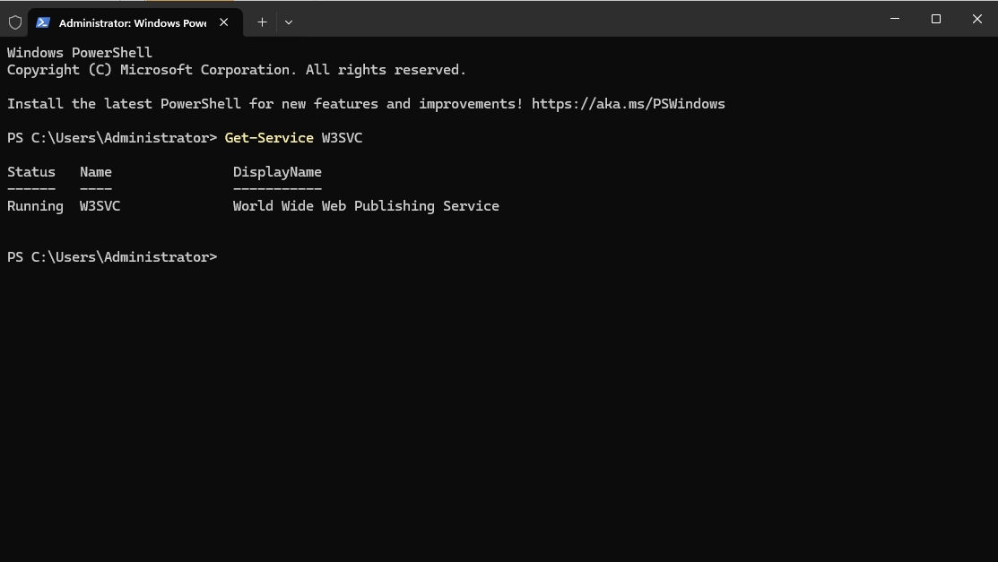

2: Configuration of the Default Website
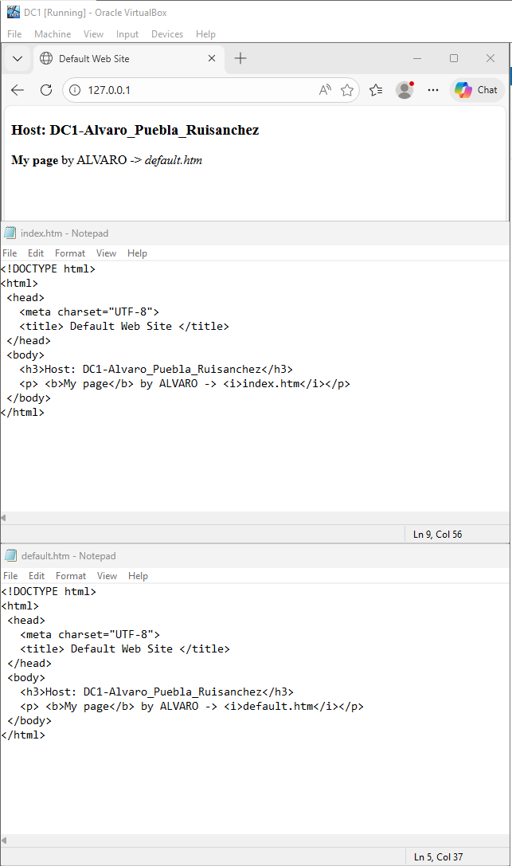
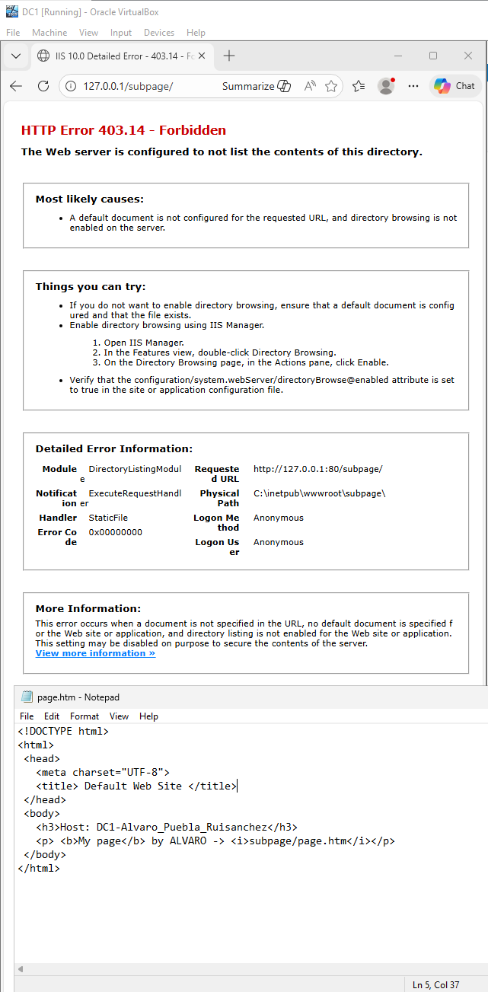
The default document priority order in IIS is:
- default.htm
- default.asp
- index.htm
- index.html
- iisstart.htm
So when default.htm exists, it is served first. Once renamed to .bak, IIS skips it and falls through to index.htm.
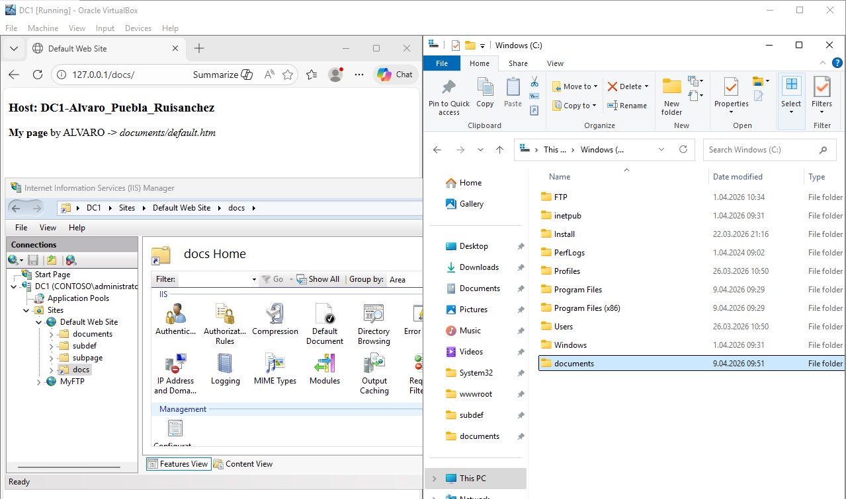
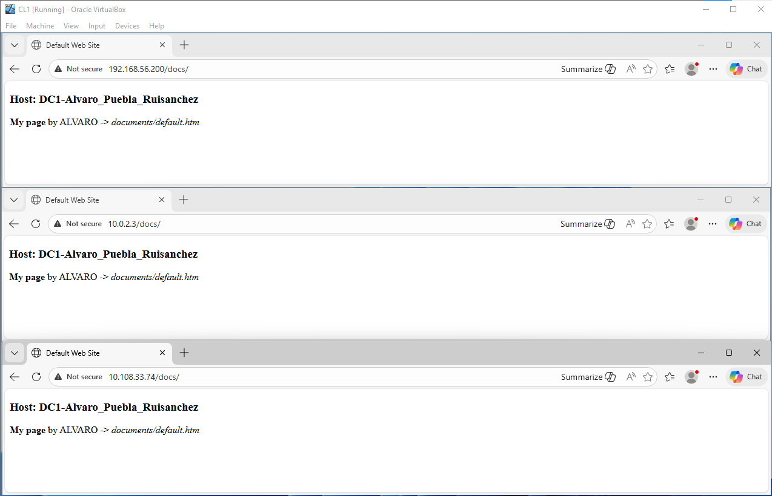
3: Configuration of Website Bindings (IP, Ports, Hosts)
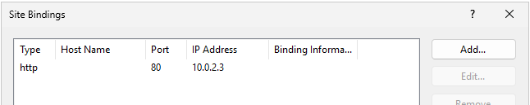
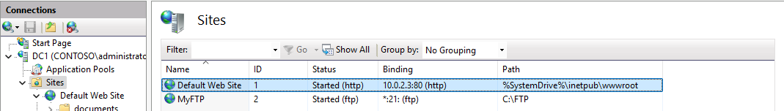
Screenshot in client:
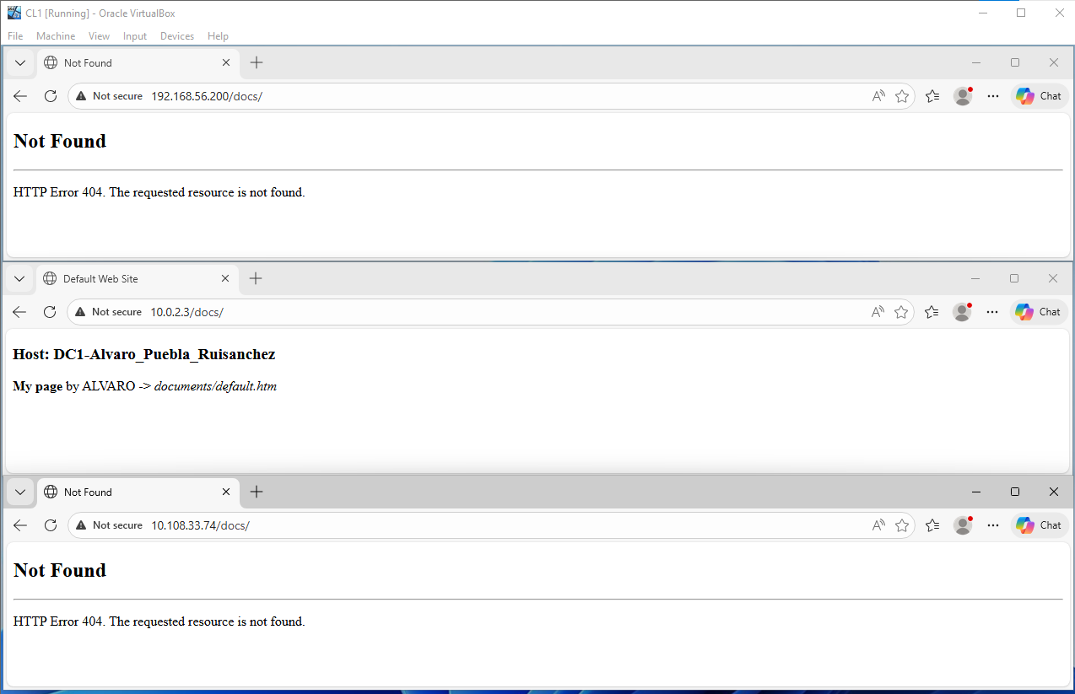
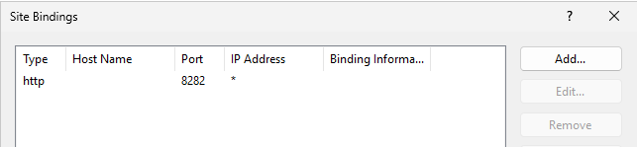
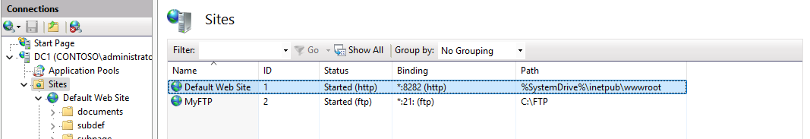
As the firewall is on:
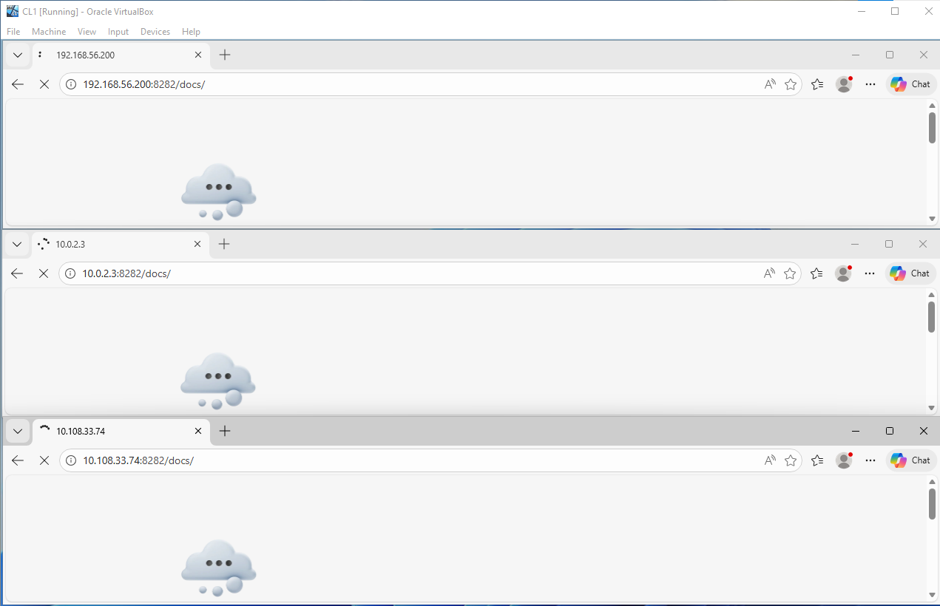
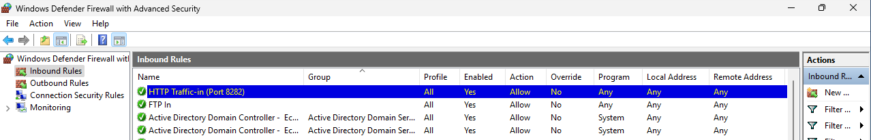
So it finally works:
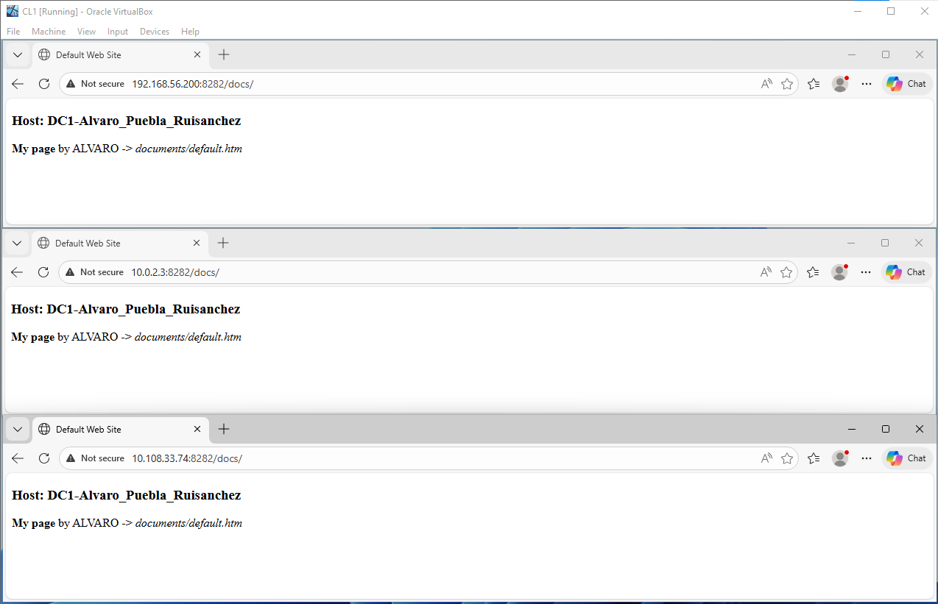
And not with the other port:
